**MRU Curriculum**

This proof-of-concept web application was created Tyler Rop, Bachelor of Computer Information Systems Student at Mount Royal University (MRU).

**General**

The current version of MRU Curriculum is an online course submitting application that allows registered users to create requests for new programs at MRU. The application is fully responsive and scales accordingly well for desktop, tablet, and smartphone usage. Users can view requests based on varying criteria such as all requests, their own requests, pending requests, approved programs, and unapproved programs. Requests are approved once a majority or all required users of the system approve the request. The application has been designed in the back-end level to be able to account for course submissions in the future (course requests have not been included at this time due to time constraints). Search functionality is prepared to be developed into the system in the future.

**Assumptions**

* Program requests are deemed more important than Course requests (they have been the key focus of development).
* Course submissions can be developed in the future.
* Search can be developed in the future to look through both Program and Course submissions.
* Responsiveness and an easy to navigate application is of the utmost important.
* It takes at least a majority approval vote for requests to be approved by a council.
* Having a request change from user creation to approved demonstrates the desired concept of the system.
* Only inheritance based class diagrams are necessary for UML representation of the system.

**Technical Information**

* PHP Version 5.5.12 was the primary language used to develop the web application. Paul DeRose and primarily Anthony Thomasson worked in conjunction with Tyler Rop to create code for the classes in the application.
* HTML5 is used to simplify code where applicable.
* JavaScript is not needed for any functionality.
* The Bootstrap 3.0.0 framework is utilized for front end design and presentation. Some elements are overridden by custom CSS code.
* WAMP Server 2.5 was used to locally develop and test the machine using Apache 2.4.9. Please import the database SQL file into your local server for proper testing.
* WebKit browsers such as Google Chrome and Firefox are best used to interact with the application.
* MySQL powers the database that the application utilizes. Paul DeRose and Anthony Thomasson worked in conjunction with Tyler Rop to create this database.
* User account passwords are encrypted into the database using MD5 for a layer of security over plain text.
* Automatic emailing details about newly created requests will be developed in future versions.

**User Log-In Information (Test Only)**

|  |  |  |
| --- | --- | --- |
| **Username** | **Password** | **Name** |
| trop315@mtroyal.ca | student | Tyler Rop |
| [rhoar@mtroyal.ca](mailto:rhoar@mtroyal.ca) | bcischair | Ricardo Hoar |
| ddocherty@mtroyal.ca | presidentMRU | David Docherty |
| [jkidney@mtroyal.ca](mailto:jkidney@mtroyal.ca) | prog_prof | Jordan Kidney |
| rconnolly@mtroyal.ca | web_prof | Randy Connolly |

**Contact**

For any questions or inquiries please contact Tyler Rop via email ([trop315@mtroyal.ca](mailto:trop315@mtroyal.ca)) or phone (403.909.1364) for assistance.

**Database Model**

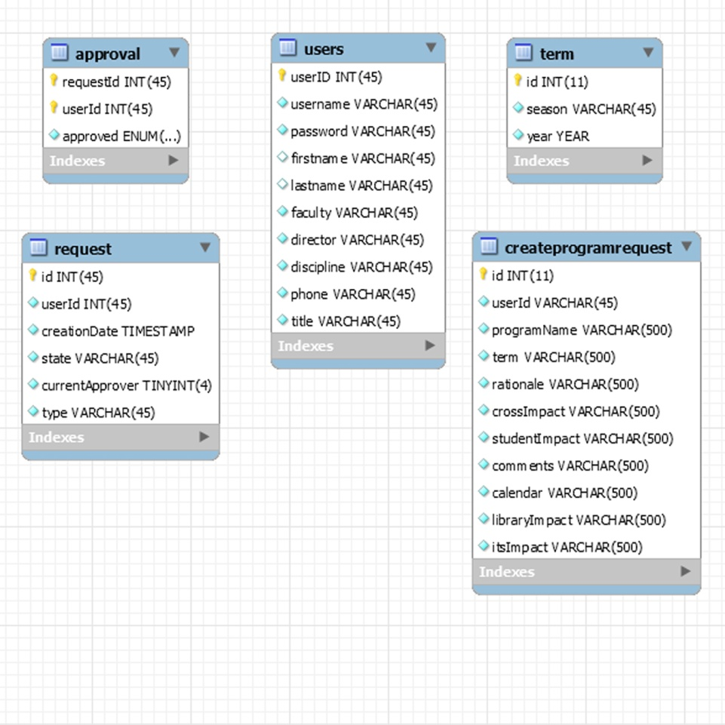

**Class Diagrams**

Classes developed in conjunction with Anthony Thomasson and Paul DeRose.

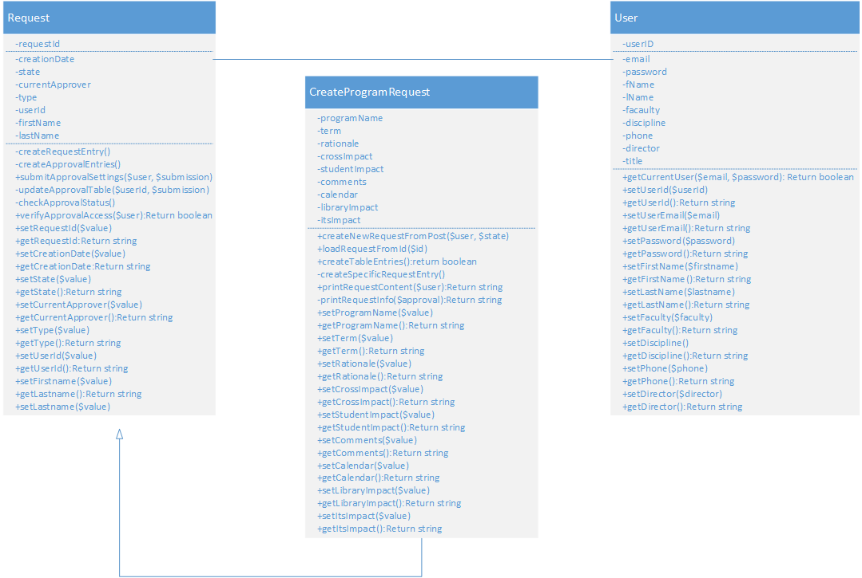

**Use Cases**



